

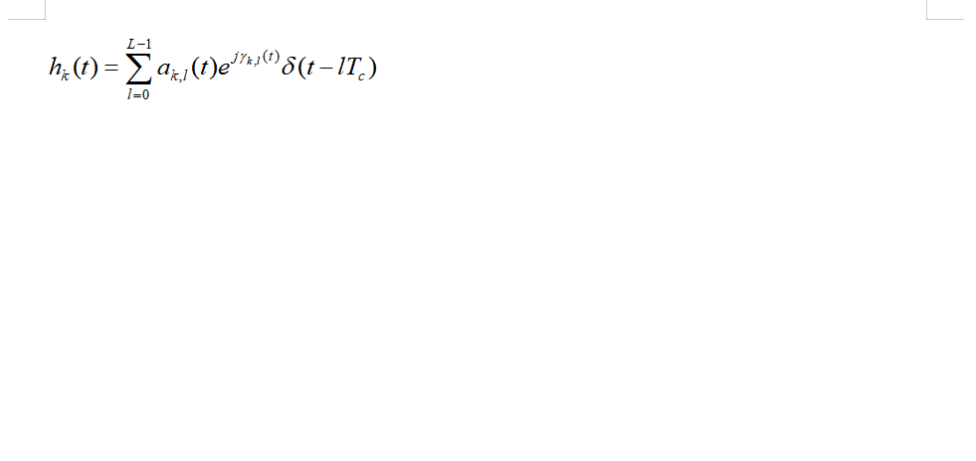



# 一级标题

正文

|  |  |  |
| --- | --- | --- |
| 1 | 1 | 1 |
| 1 | 1 | 1 |
| 1 | 1 | 1 |